**Please note if your codes don’t compile, they will be given 0 mark.**

**You can decide any unmentioned details by yourself including but not limited to adding any necessary data attributes or methods, etc.**

Please create an application the name of which is **Your_First_Name**. It has a **Treasure** class and a **Player class** implement a simple GUI based game.

1. (**20 marks**) Please create the GUI for the game, which has the components as below (you can add any other components you need)

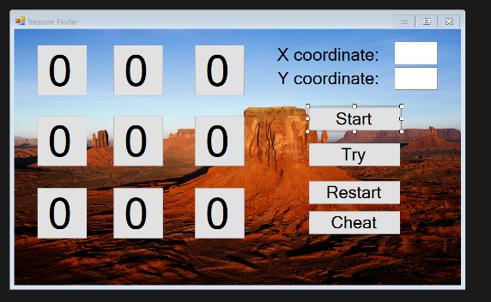

Label

Text box

Here are two requirements:

1. Change the caption (text) of your form to Treasure Finder
2. Add a background image to the form

You can decide other the detailed design of your GUI.

The nine buttons with 0 (0 means this spot hasn’t been attempted yet) is the “map” where the treasure is hidden under one of the spots, the coordinate is ranging from (0,0) to (2,2), where (0,0) is the left upper corner and (2,2) is right bottom corner.

The functions of the other 4 buttons, Start, Try, Restart and Cheat will be discussed later.

1. **(10 marks)** Please create a **Treasure** class, which has (at least) those attributes:

**coordinate**: the location of the oil well, it has two coordinates:

**int x; int y;**

**value**: the value (**int values**), this one **MUST** be **private**;

Please create the constructor to initialize the attributes. You can decide the type and modifier of those attributes (except value, which is private), but using int will be simpler**.**

**DrillDistance():** give the distance of the **Treasure** from the drilling position.

Assume the drilling position is (**xd, yd**) the coordinate of the Treasure is (**x,y**), thus the distance is calculated as:

Distance = Math.Abs(x-xd)+ Math.Abs(y-yd);

As you can see the distance is not Euclidean distance, we can think it is because the distance estimation in field is not accurate 😊

**Please note, you might need to pass the xd, yd into this method as they are defined outside the Treasure** **class.**

1. **(5 marks)** Please create a **Player** class, which has (at least) those attributes:

**name**: the name of the investor (**string name**);

**collect**: the value collected (int collect);

**drill position**: the coordinate of the drilling

**int xd; int yd;**

Please create the constructor to initialize the attributes. You need to decide the type and modifier of those attributes**.**

1. **(35 marks)** Finish the game simulate the procedure of looking for the treasure. The functions of the three buttons are given as:
   1. **Start button**: when this button is clicked, create an array of Treasure (the size of which is 2), then you can use the table below to initialize the Treasure objects.

|  |  |  |  |
| --- | --- | --- | --- |
| index | X coordinate | Y coordinate | Value |
| 0 | 2 | 1 | 1000 |
| 1 | 0 | 1 | 6000 |

Then create a Player object with the following information:

|  |  |  |  |
| --- | --- | --- | --- |
| Name | Drill position x | Drill position y | collected |
| Player | 0 | 0 | 0 |

* 1. **Try button**: when the try button is clicked, the drilling coordinates x and y will be read form the textboxes.
     1. If the coordinates values are invalid, please pop up a message box “Invalid coordinates!” and clear the two text boxes. Then you don’t need to do anything, just return.
     2. If any one of the treasures is found, please pop up a message box “Congrats! You found the treasure with aa attempt. The value is vv.”, where aa stands for the number of attempts and vv stands for the value found. Meanwhile, the corresponding spot on the map will be changed from 0 to 1 and the player’s collect value will also be updated.
     3. If the attempted position doesn’t have the treasure, please pop up message box “Sorry, you missed and the distance is dd.”, where dd is the distance from the current attempted position to the actual position of the treasures (the closer one). It is calculated by invoking the method **DrillDistance(). Besides, also update the corresponding spot on the map from 0 to X to indicate that this position has been attempted but no luck.**
  2. **Restart button**: restart the game by clear the map and re-create the Treasure array and player object.
  3. **Cheat button**: Toggle to show/hide the position of the Treasures by showing 1 at the given position of the map.